LangChain Overview:

What is LangChain
LangChain is an open-source library designed to simplify the process of building LLM based applications. It provides modular building blocks that let you create sophisticated LLM-based workflows with ease.

LangChain consists of multiple components
1. Model components gives use a unified interface to interact with various LLM providers
2. Prompts component helps you engineer prompts
3. Retrievers component helps you fetch relevant documents from a vector store
But the biggest offering of LangChain is Chains.

What can you do with LangChain
1. Simple conversational workflows like Chatbots, Text Summarizers
2. Multistep workflows
3. RAG applications
4. Basic Level Agents

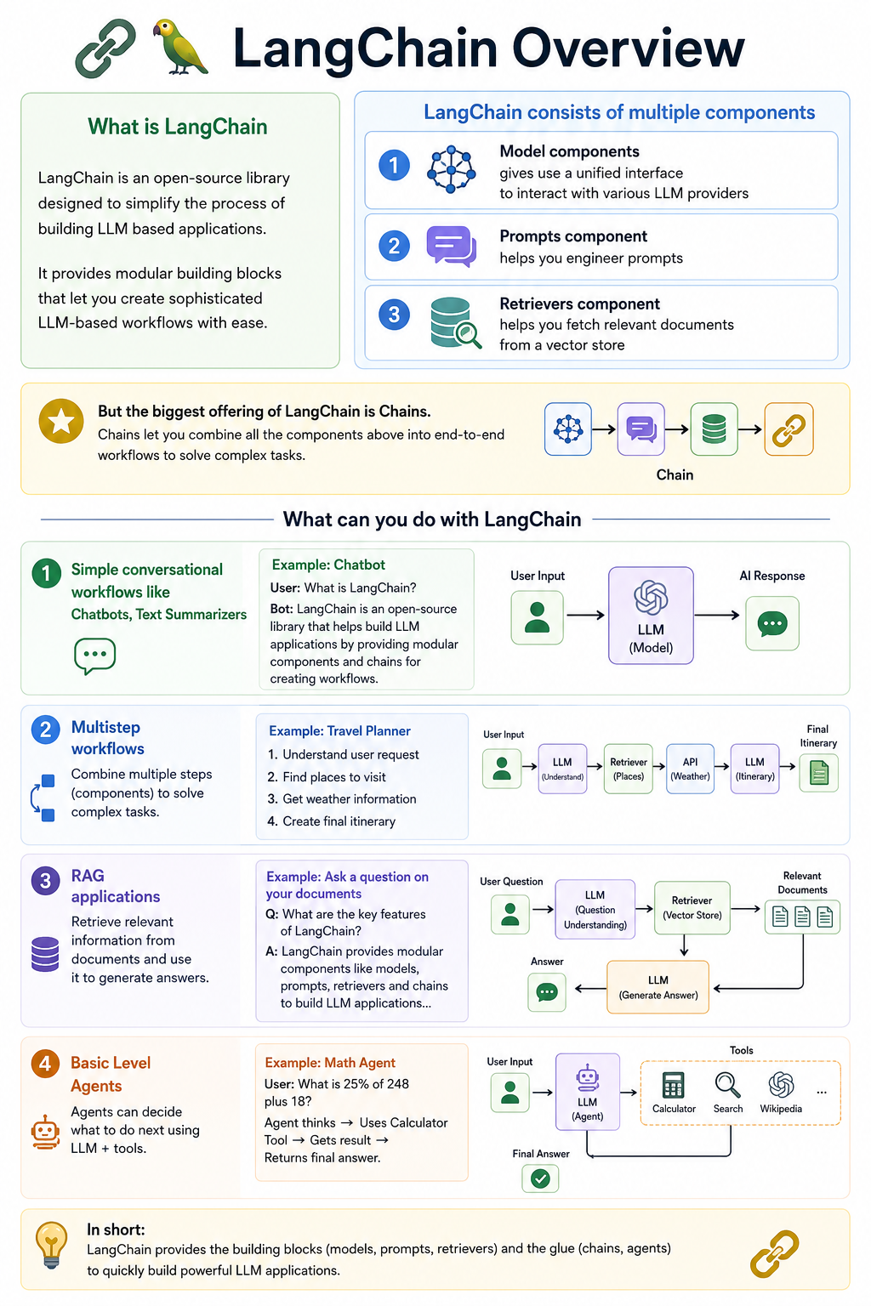

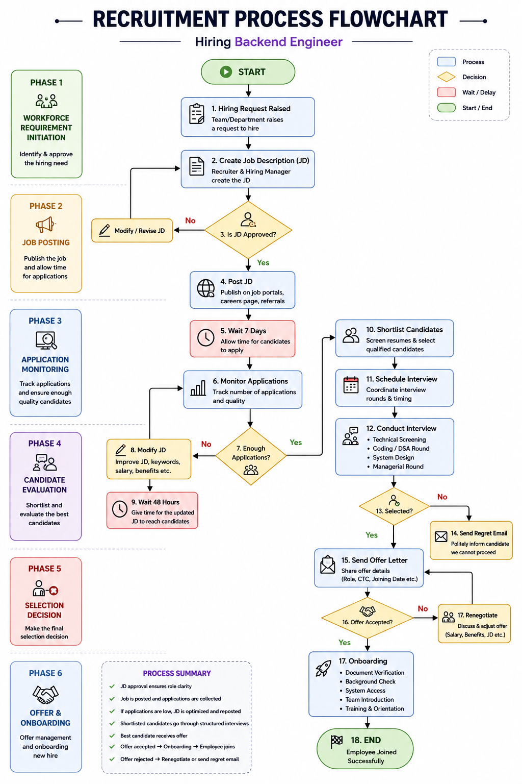

Detailed Workflow Explanation
Phase 1 — Workforce Requirement Initiation
1. Hiring Request Raised
The process starts when a team or department identifies the need for a Backend Engineer.
Examples:
- New product development
- Team expansion
- Employee resignation
- Increased workload
Output:
Backend Engineer required

2. Create Job Description (JD)
The recruiter and hiring manager prepare the Job Description.
A typical Backend Engineer JD includes:
- Python / Java / Node.js
- REST APIs
- Databases
- Cloud Platforms
- Microservices
- Experience level
- Salary range
Output:
Backend Engineer JD Created

3. JD Approval
The JD is reviewed by:
- Engineering Manager
- HR Manager
- Finance Team (if required)
Decision:
Is the JD approved?
If No
The JD is revised and sent for approval again.
Loop:
Create JD
↓
Approval
↓
Rejected
↓
Modify JD
↓
Approval Again
If Yes
Move to recruitment.

Phase 2 — Job Posting
4. Post JD
The approved JD is published on:
- LinkedIn
- Naukri
- Indeed
- Careers Page
- Internal Referral Portal
Output:
Backend Engineer opening is live

5. Wait 7 Days
Allow time for candidates to apply.
Purpose:
- Generate applicant pool
- Increase visibility
- Collect resumes

Phase 3 — Application Monitoring
6. Monitor Applications
Recruiters continuously track:
- Number of applications
- Candidate quality
- Relevant experience
Example:
Applications Received: 15
Qualified Candidates: 4

7. Enough Applications?
Decision Point:
Do we have enough qualified candidates?

Path A: Not Enough Applications
8. Modify JD
Improve:
- Job title
- Skill requirements
- Salary range
- Keywords
- Remote options
Example:
Backend Engineer
↓
Senior Backend Engineer (Python)

9. Wait 48 Hours
After updating the JD:
- Re-index on job portals
- Reach new candidates
Then return to:
Monitor Applications
This creates a feedback loop until enough applications are received.

Phase 4 — Candidate Evaluation
10. Shortlist Candidates
Recruiters select qualified candidates based on:
- Skills
- Experience
- Education
- Relevant projects
Example:
50 Applicants
↓
8 Shortlisted

11. Schedule Interview
Coordinate:
- Interview panels
- Candidate availability
- Technical rounds
Output:
Interview scheduled

12. Conduct Interview
Interview stages may include:
Technical Screening
- Python
- APIs
- Databases
Coding Round
- DSA
- Backend design
System Design
- Scalability
- Architecture
Managerial Round
- Team fit
- Communication

Phase 5 — Selection Decision
13. Selected?
Decision:
Did the candidate pass all rounds?

Path A: Not Selected
14. Send Regret Email
Politely notify the candidate.
Example:
Thank you for your interest.
Unfortunately, we have decided not to move forward.
Candidate exits process.

Path B: Selected
15. Send Offer Letter
Offer includes:
- Role
- Salary
- Joining Date
- Benefits
Output:
Offer Released

Phase 6 — Offer Management
16. Offer Accepted?
Decision:
Did the candidate accept the offer?

Path A: Accepted
17. Onboarding
Activities:
- Document Verification
- Background Check
- System Access
- Team Introduction
- Training
Output:
Employee Joined Successfully

18. End
Recruitment process completed.

Path B: Rejected
17. Renegotiate
Discussion around:
- Salary
- Benefits
- Joining Date
- Remote Work
Possible outcome:
Candidate accepts revised offer
Then return to:
Send Offer Letter
The negotiation loop continues until:
- Offer Accepted
or
- Candidate Withdraws

Complete Business Flow Summary
Hiring Need
↓
Create JD
↓
Approval
↓
Post Job
↓
Collect Applications
↓
Monitor Candidate Pool
↓
Shortlist
↓
Interview
↓
Selection Decision
↓
Offer Management
↓
Onboarding
↓
Employee Joins

CODING
#Step1
hiring_prompt = "We need to hire a Software Engineer for our backend team."

# Step 2: Create JD using LLM
11m = ChatOpenAI(model="gpt-4", temperature=0)
jd_prompt = ChatPromptTemplate. from_template(
"Create a job description based on the hiring request:\n\n{request}"
jd_chain = jd_prompt | llm | StroutputParser()

# Step 3: Approval function
def approve_jd(jd: str) -> bool:
# Simulate approval logic
return "Approved"

# Step 4: Post JD function
def post_jd(jd: str):
print("pD Approved and Posted: \n")
)

This is Glue code

# Step 5: Loop until JD is approved
approved = False
jd_output = None

while not approved:
jd_output = jd_chain.invoke({"request": hiring_prompt})
print(jd_output)

approved = approve_jd(jd_output)

if not approved:
print("JD not approved. Regenerating ... \n")

# Final Step
if approved:
post_jd(jd_output)

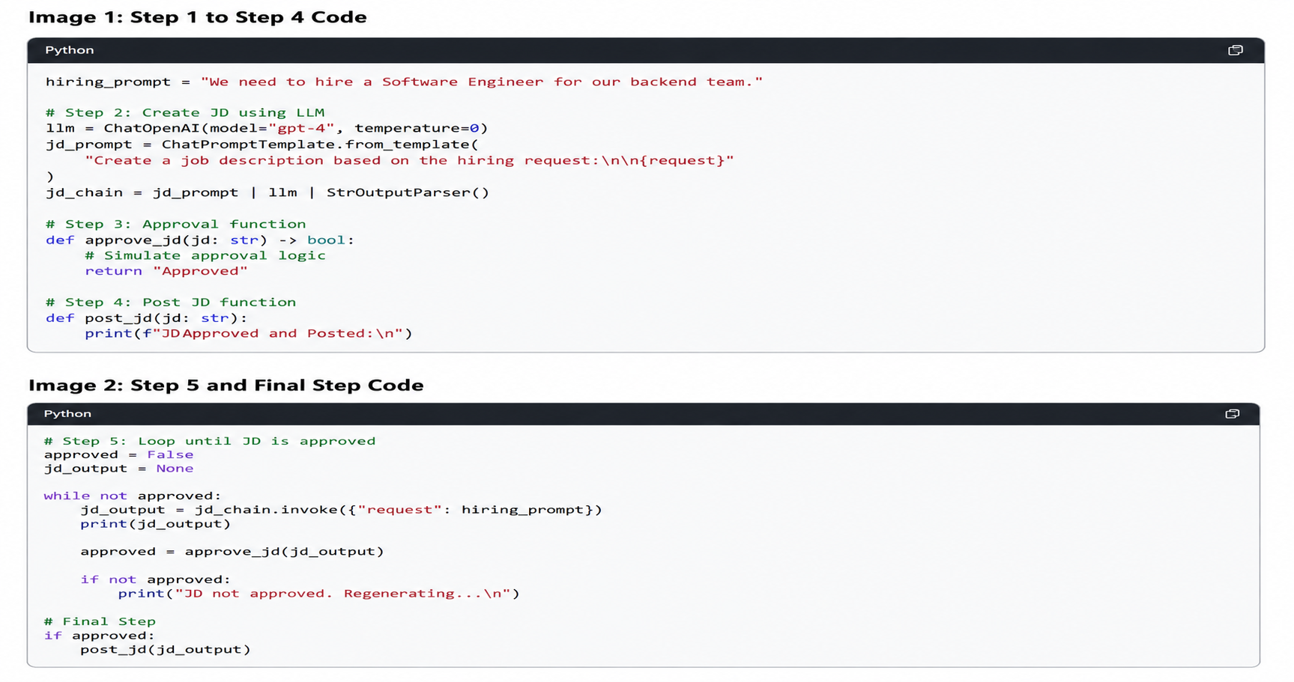

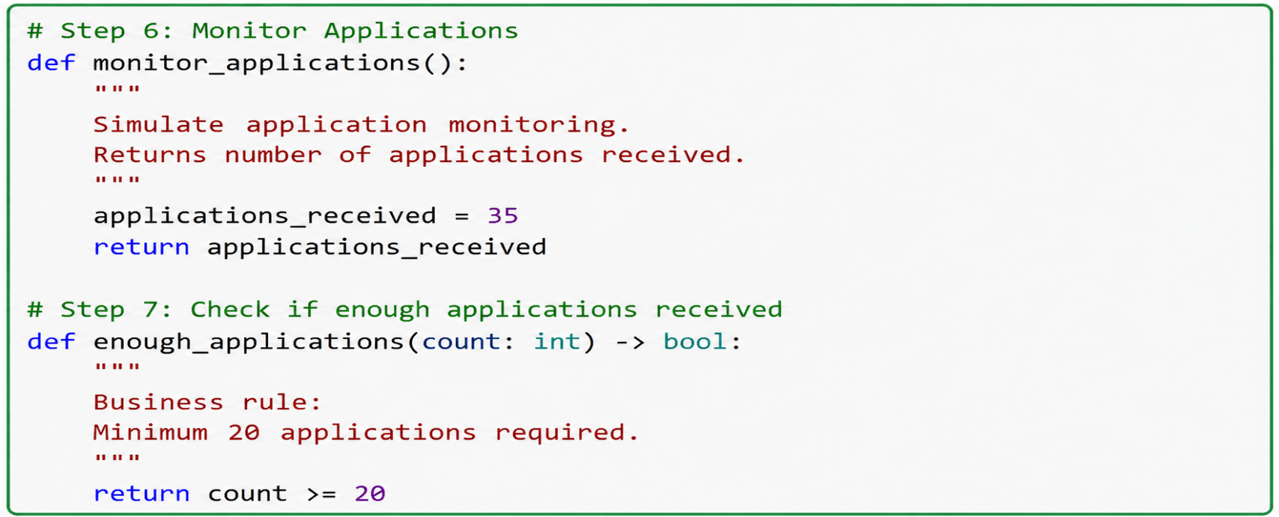

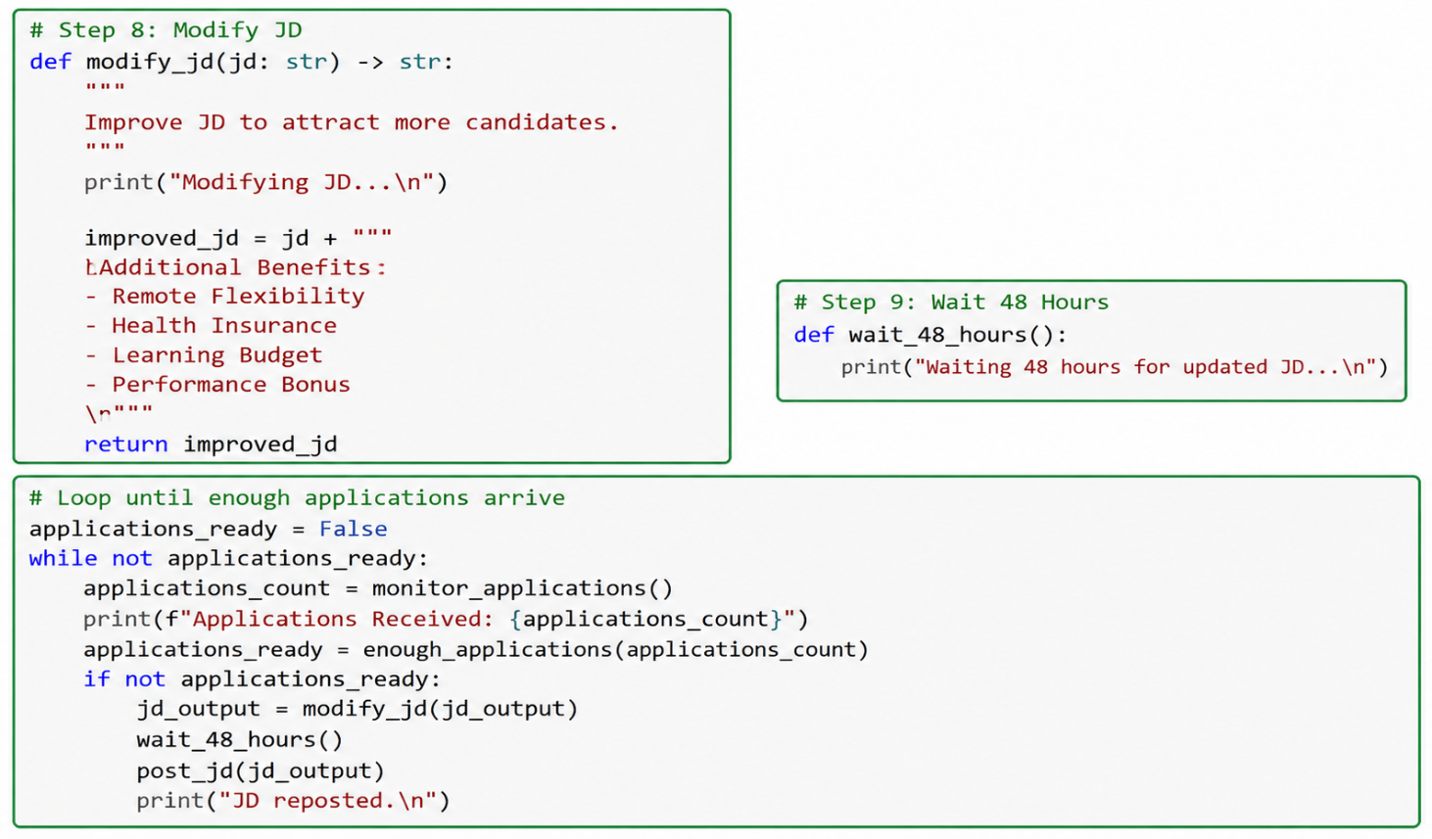

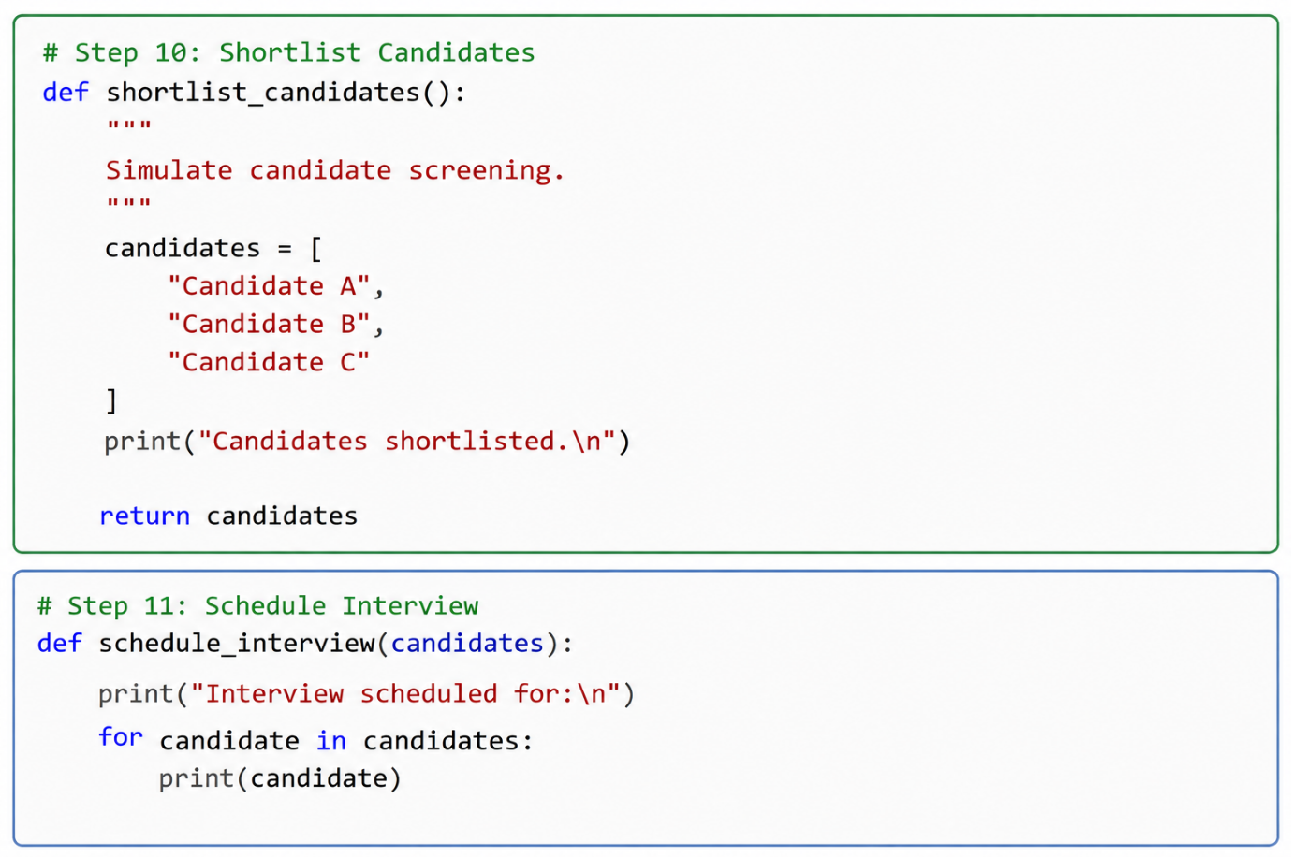

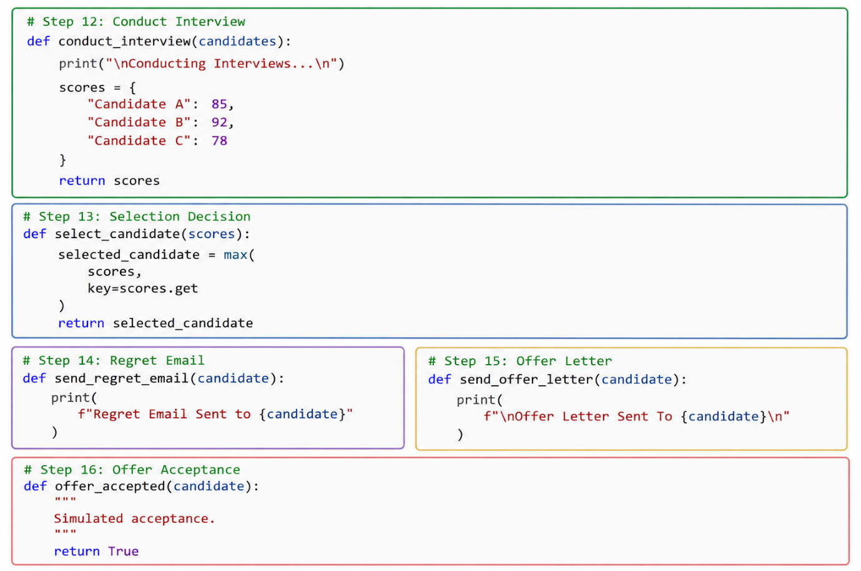

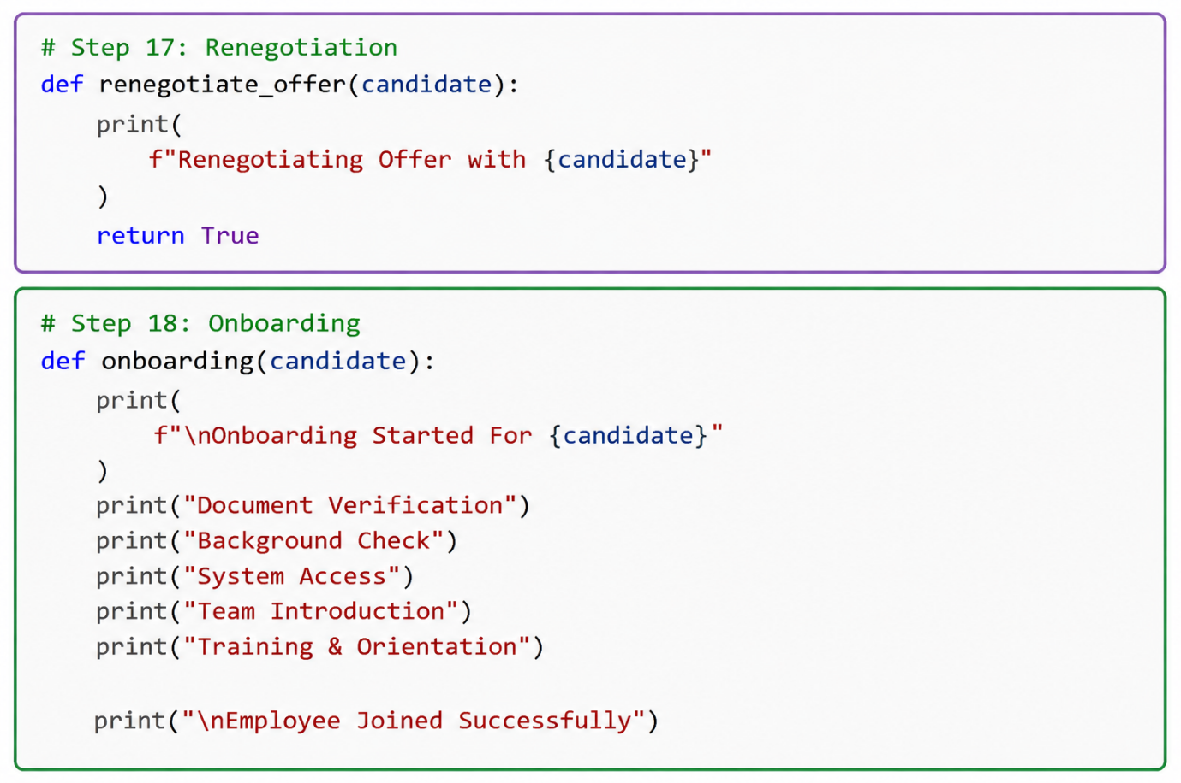

creating
LangGraph Implementation for avoid glue code for agentic application

graph.add_node("HiringRequest", hiring_request)
graph.add_node("CreateJD", create_jd)
graph.add_node("CheckApproval", check_approval)
graph.add_node("PostJD", post_jd)

graph.add_edge("HiringRequest", "CreateJD")
graph.add_edge("CreateJD", "CheckApproval")

graph.add_conditional_edges(
"CheckApproval",
approval_router,

"approved": "PostJD",
"not_approved": "CreateJD" # Loop back

graph.add_edge("PostJD", END)

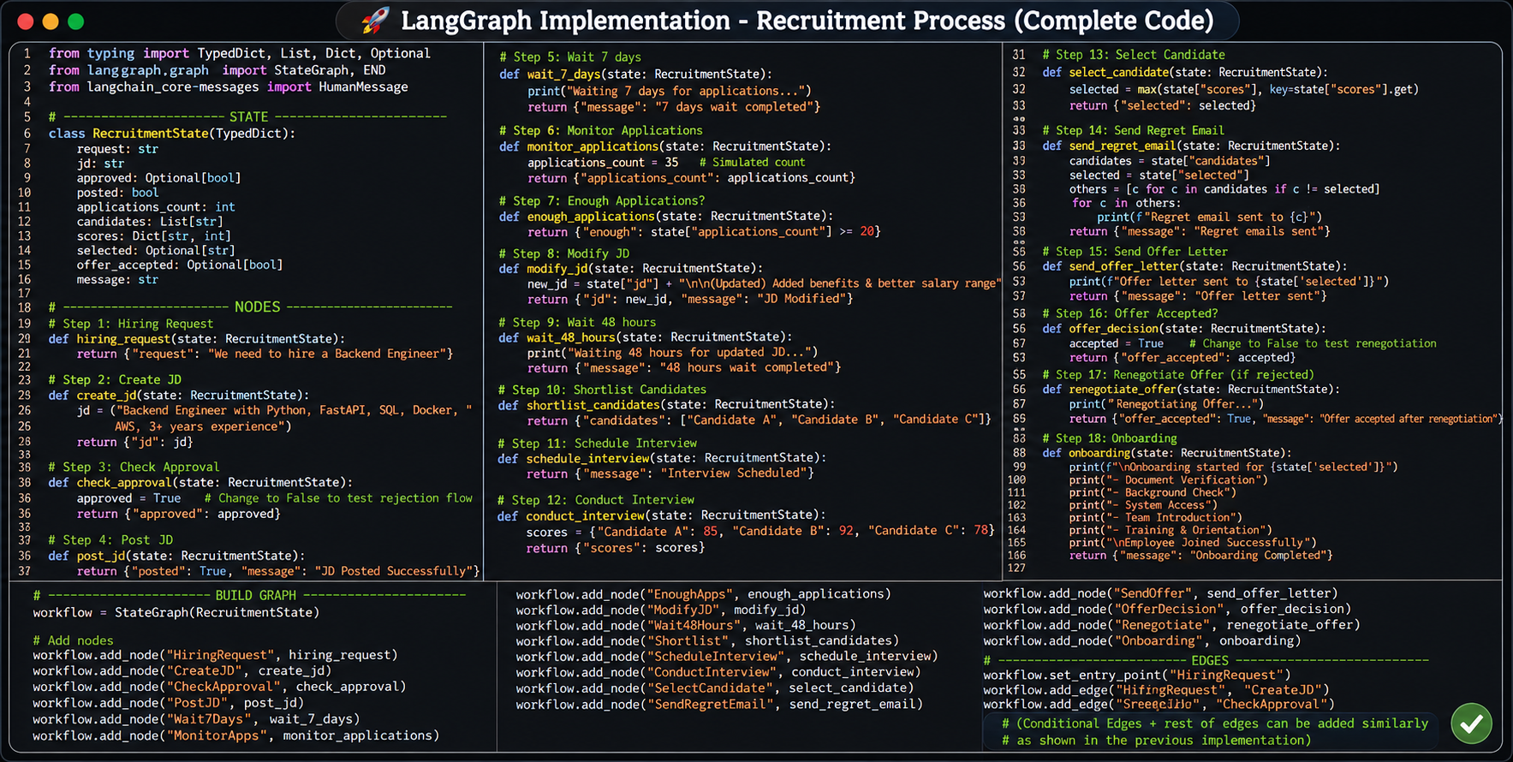

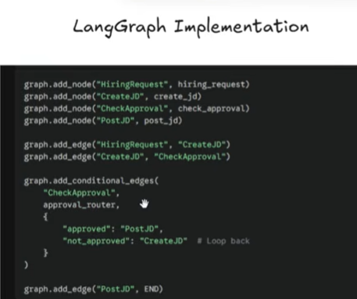
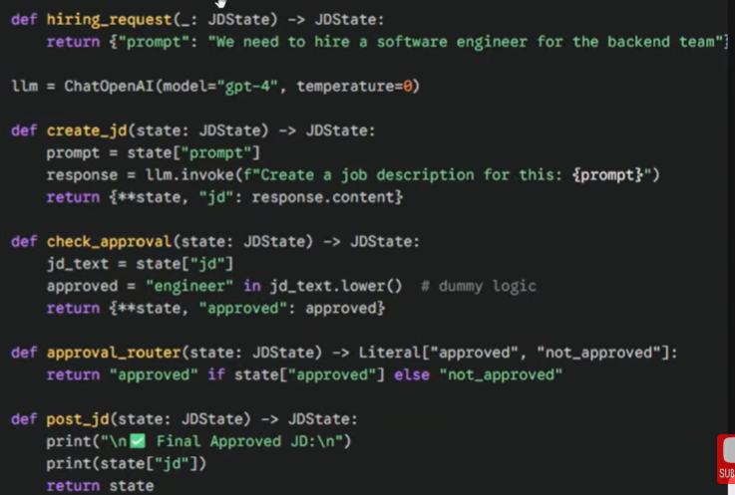

Challenges IN Langchain

1. Control Flow Complexity
1. Conditional branch
2. loops
3. Jump

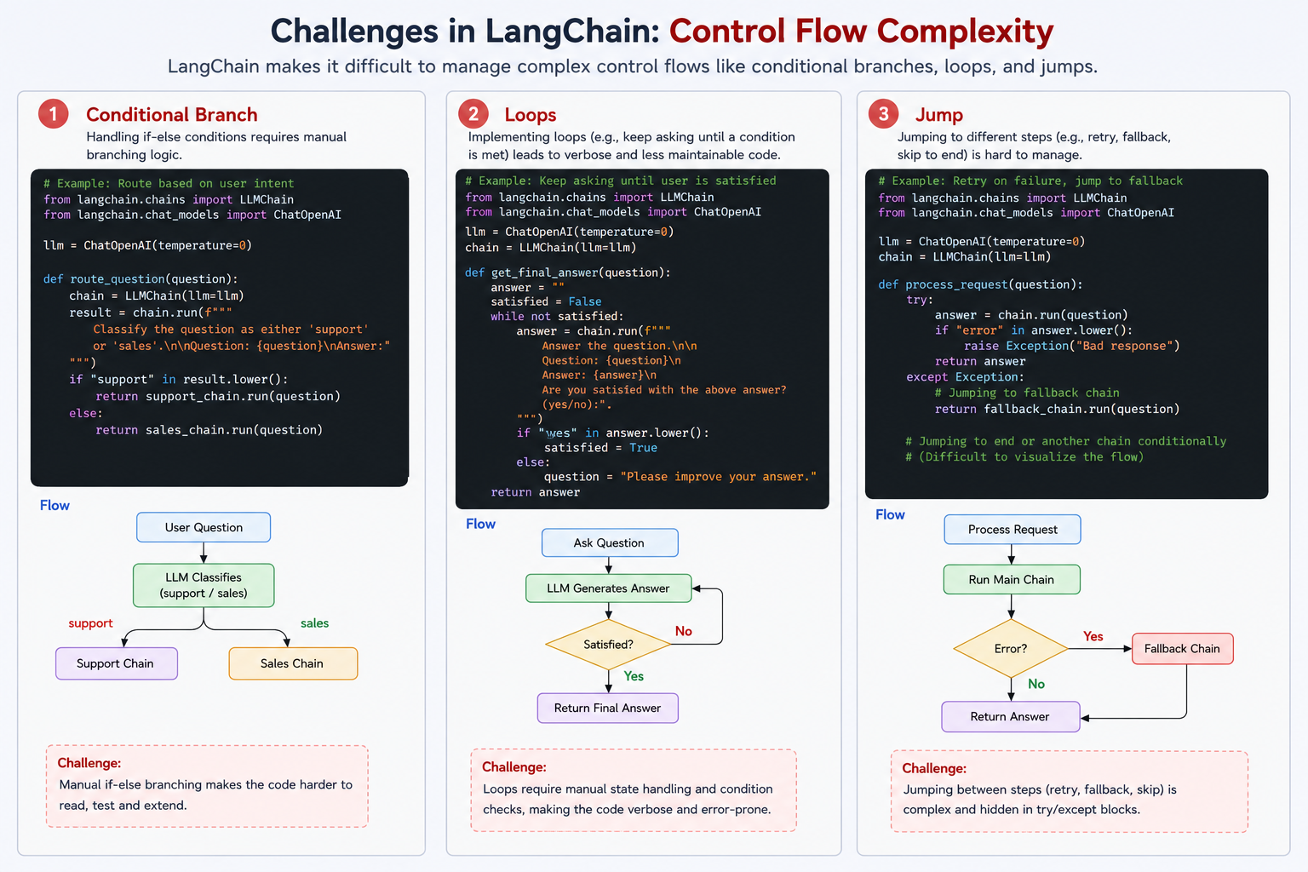

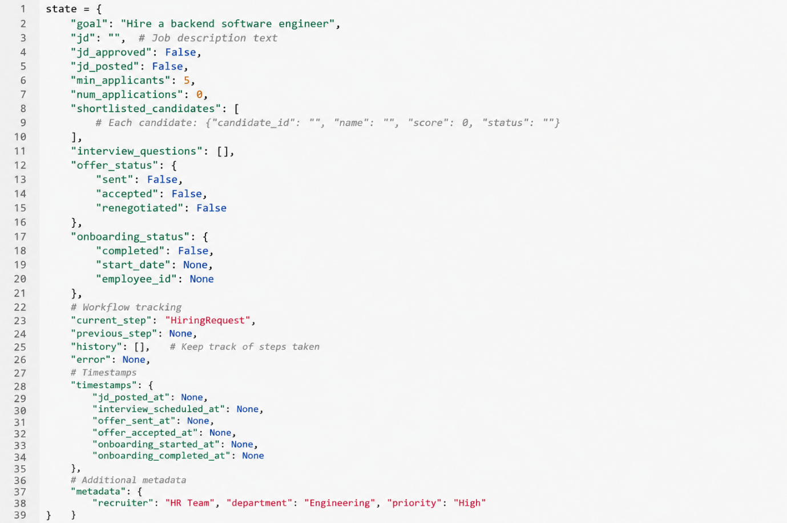

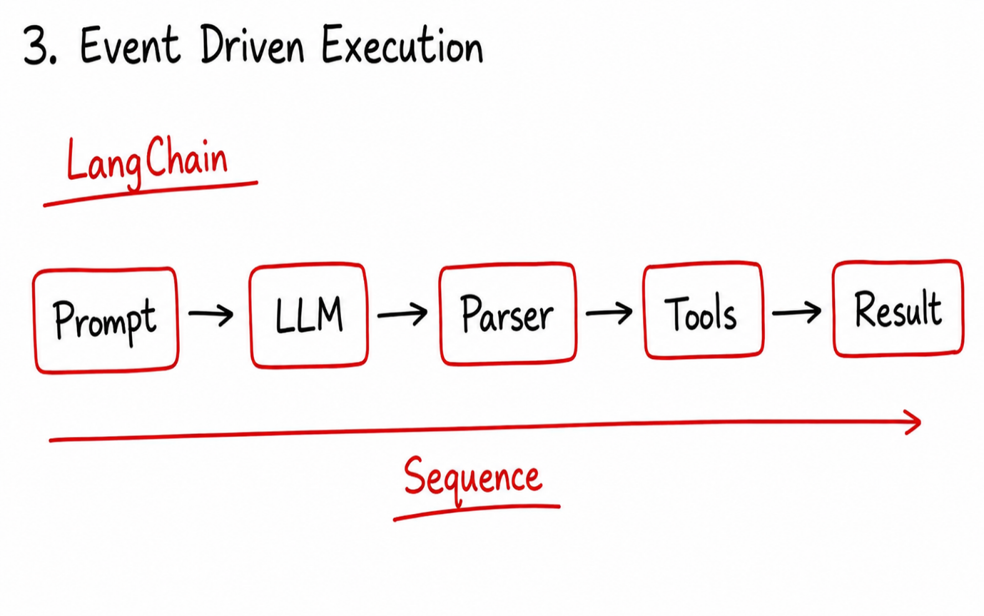

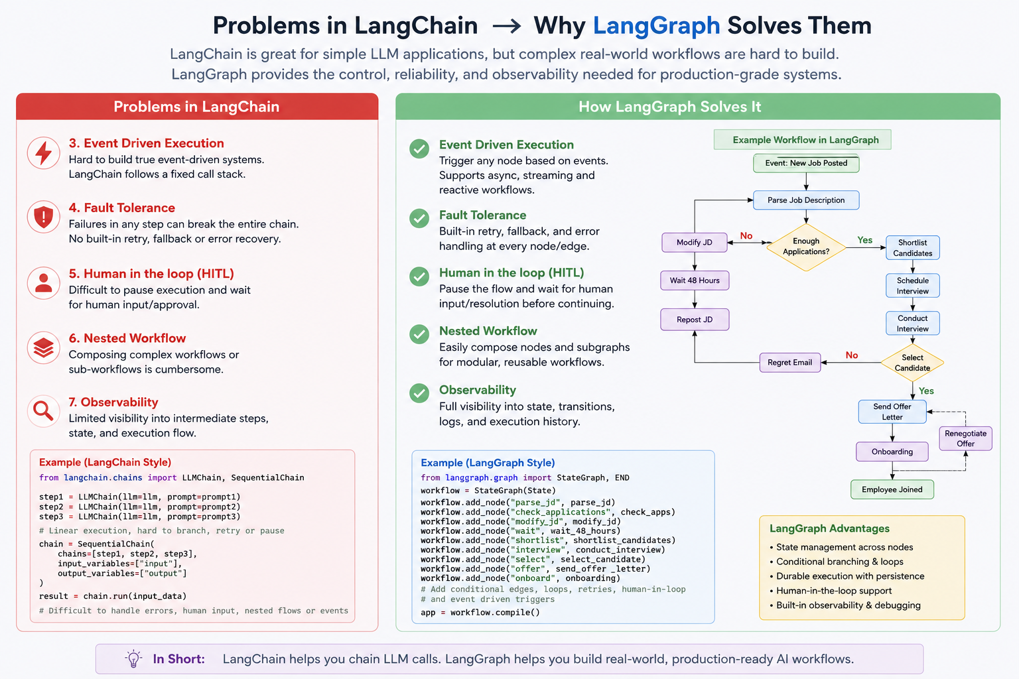

LangGraph Overview:
1. What is LangGraph?
LangGraph is an orchestration framework that enables you to build stateful, multi-step, and event-driven
workflows using large language models (LLMs). It's ideal for designing both single-agent and multi-agent agentic
Al applications.
Think of LangGraph as a flowchart engine for LLMs - you define the steps (nodes), how they're connected
(edges), and the logic that governs the transitions. LangGraph takes care of state management, conditional
branching, looping, pausing/resuming, and fault recovery - features essential for building robust, production-
grade Al systems.

2. When to Use What?
. Use LangChain when you're building simple, linear workflows - like a prompt chain, summarizer, or a basic retrieval system.
. Use LangGraph when your use case involves complex, non-linear workflows that need:
o Conditional paths
o Loops
o Human-in-the-loop steps
o Multi-agent coordination
o Asvnchronous or event-driven execution

3. Should We Still Use LangChain?
Yes. LangGraph is built on top of LangChain - it doesn't replace it.

You'll still use LangChain components like:
ChatOpenAI (LLMs)
PromptTemplate
Retrievers
DocumentLoaders
Tools , etc.

LangGraph handles workflow orchestration, while LangChain provides the building blocks for each step in
that workflow.

